REPORTS – STATEMENT OF FINANCIAL POSITION

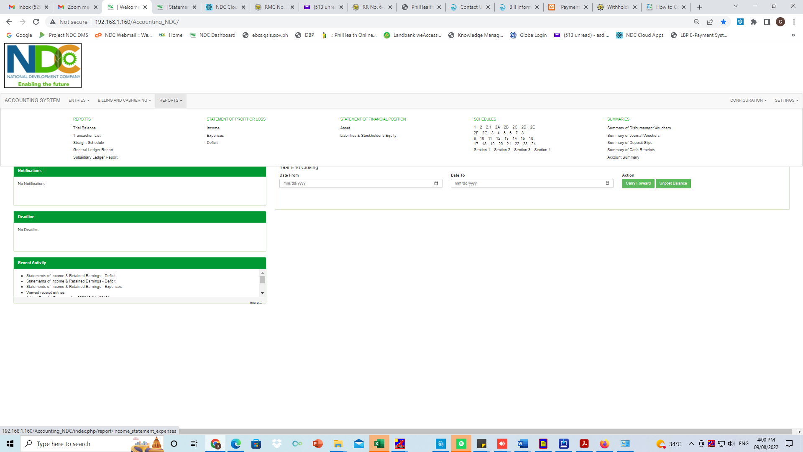

FINANCIAL POSITION

* ASSETS

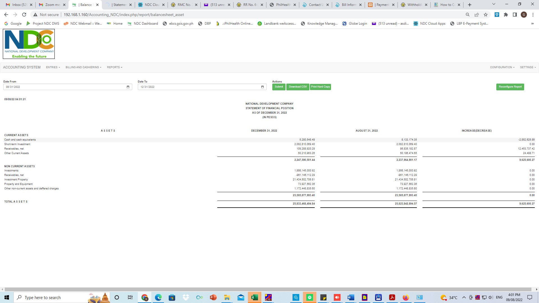

FINANCIAL POSITION

* LIABILITIES AND STOCKHOLDER’S EQUITY

